Presentation Content Structure

**Table Of Contents**

1. Project Introduction
2. System Architecture
   1. System Architecture Diagram
   2. CICD Pipeline
   3. Database Design
3. Actors And Features
4. Demonstration
   1. Demo 1: Tracking feature
   2. Demo 2: Administration feature
5. Outcomes

**I. Introduction (Thanh Hưng)**

* Team Introduction: Introduce team members and roles.
* Project Introduction: Overview, objectives, and references (Mamibabi, Baby Center, Babiuni).
* Context Diagram

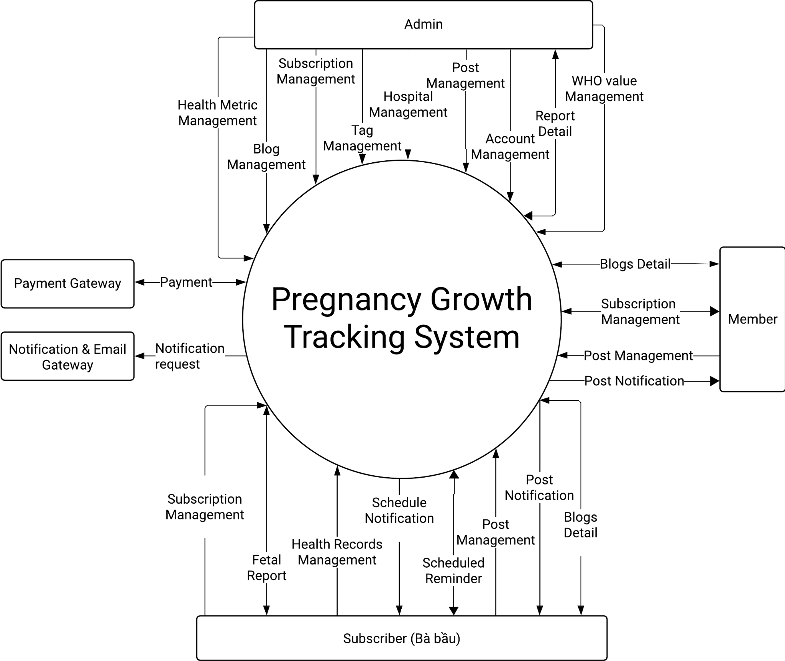

## **II. System Architecture (Nam Hoàng)**

* **System Architecture Diagram**

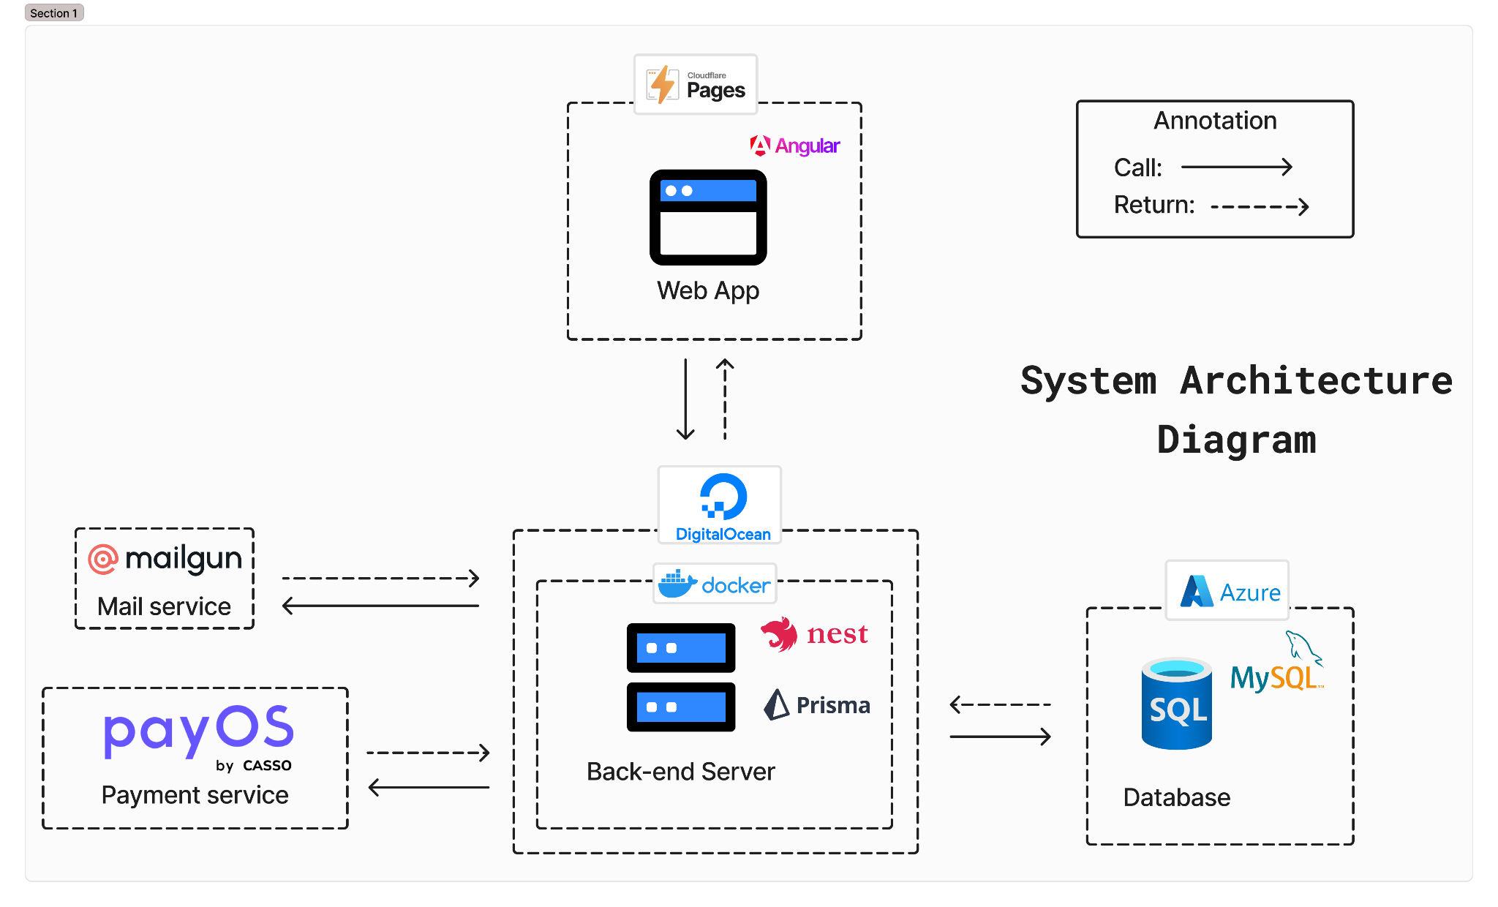

* **CICD Pipeline**

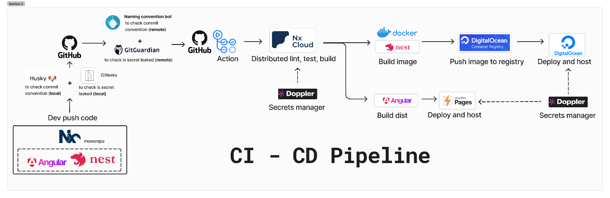

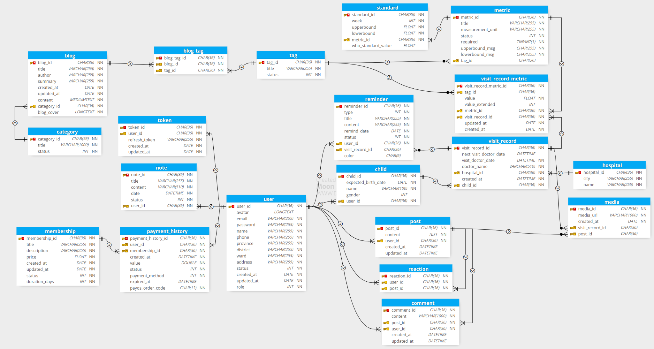

**III. User Roles & Feature Map (Thanh Hưng)**

* **Actors**: Guest, Member (Unpaid), Subscriber (Paid), Administrator.
* **Features**:
  + **Tracking & Evaluating pregnancy metrics**
    - Tracking records
    - Calendar
    - Report summary
    - Alert & Notification
  + **Community & Blogs**
  + **User Management**
  + **Administration**

**IV. Demonstration**

**4.1. Flow 1: Tracking feature (Việt Thành)**

* Registration to provide **expected birthdate**
* Membership subscription
* Create a tracking record
* View health metrics on **line chart**
* View all **warning messages**
* View all records in table
* Edit record detail
* Share record
* Create reminder by **next visit hospital date**
* View reminder in home page
* Reminder management
* Send notifications to email
* Profile management:
  + Children profile management
  + User profile management

**4.2. Flow 2: Blog and community feature (Việt Thành)**

* **Blogs:** Suggestion blogs (Based on tracking result)
* **Community**

**4.3. Flow 3: Administration feature (Tấn Phát)**

* **Dashboard:** Analytics & Reporting.
* **Metrics Management:** Health Metrics Management.
* **User Management**
* **Membership Management**.
* **Content Management:** Blog, Category, Tag.
* **Payment History:** Transaction records.

**V. Project Outcomes (Việt Thành)**

* **Requirement Fulfillment:**
  + Tracking & evaluation from system
  + Reminders & alerts
  + Blogs & Community
* **Assessment**:
  + **Strengths**: UX/UI, CI/CD Pipeline.
  + **Weaknesses**: Performance issues, limited pregnancy features.